STAT 6340 Mini Project 3

Matthew Lynn

March 11, 2019

# Section 1

Section 2 is coded in Section 1

# library and function for plotting decision boundaries later  
library(caret)  
decisionplot <- function(model, data, class = NULL, predict_type = "class",  
 resolution = 125, showgrid = TRUE, ...) {  
   
 if(!is.null(class)) cl <- data[,class] else cl <- 1  
 data <- data[,1:2]  
 k <- length(unique(cl))  
   
 plot(data, col = as.integer(cl)+1L, pch = as.integer(cl)+1L, ...)  
   
 # make grid  
 r <- sapply(data, range, na.rm = TRUE)  
 xs <- seq(r[1,1], r[2,1], length.out = resolution)  
 ys <- seq(r[1,2], r[2,2], length.out = resolution)  
 g <- cbind(rep(xs, each=resolution), rep(ys, time = resolution))  
 colnames(g) <- colnames(r)  
 g <- as.data.frame(g)  
   
 ### guess how to get class labels from predict  
 ### (unfortunately not very consistent between models)  
 p <- predict(model, g, type = predict_type)  
 if(is.list(p)) p <- p$class  
 p <- as.factor(p)  
   
 if(showgrid) points(g, col = as.integer(p)+1L, pch = ".")  
   
 z <- matrix(as.integer(p), nrow = resolution, byrow = TRUE)  
 # contour(xs, ys, z, add = TRUE, drawlabels = FALSE,  
 # lwd = 1, levels = (1:(k-1))+.5)  
   
 invisible(z)  
}

# Question 1(a)

First we load in our data and explore what the data is about and see if we can pick predictors for modeling

set.seed(1)  
library(corrplot)

## corrplot 0.84 loaded

admission = read.csv("admission.csv", header = T)  
# these x columns appear but have no use so we delete them  
admission$X = admission$X.1 = admission$X.2 = admission$X.3 <- NULL  
head(admission)

## GPA GMAT Group  
## 1 2.96 596 1  
## 2 3.14 473 1  
## 3 3.22 482 1  
## 4 3.29 527 1  
## 5 3.69 505 1  
## 6 3.46 693 1

str(admission)

## 'data.frame': 85 obs. of 3 variables:  
## $ GPA : num 2.96 3.14 3.22 3.29 3.69 3.46 3.03 3.19 3.63 3.59 ...  
## $ GMAT : int 596 473 482 527 505 693 626 663 447 588 ...  
## $ Group: int 1 1 1 1 1 1 1 1 1 1 ...

summary(admission)

## GPA GMAT Group   
## Min. :2.130 Min. :313.0 Min. :1.000   
## 1st Qu.:2.600 1st Qu.:425.0 1st Qu.:1.000   
## Median :3.010 Median :482.0 Median :2.000   
## Mean :2.975 Mean :488.4 Mean :1.941   
## 3rd Qu.:3.300 3rd Qu.:538.0 3rd Qu.:3.000   
## Max. :3.800 Max. :693.0 Max. :3.000

pairs(subset(admission))

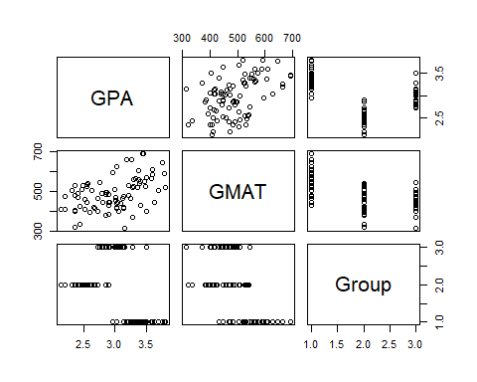

round(cor(subset(admission)), 2)

## GPA GMAT Group  
## GPA 1.00 0.46 -0.43  
## GMAT 0.46 1.00 -0.60  
## Group -0.43 -0.60 1.00

corrplot(cor(subset(admission)), method = "number", type = "upper")

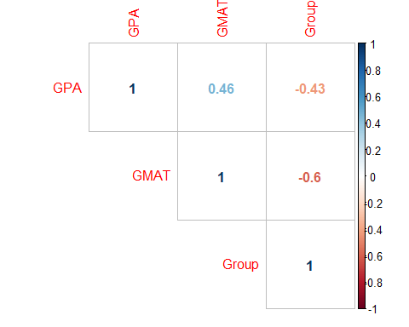 We see that GPA and GMAT have a nice relationship amongst each other. Group is categorical and would make for a great response variable.

# 1(b)

Here our goal is to use LDA, plot it with a decision boundary and compute the confusion matrix. Notes are in the comments!

set.seed(1)  
# question 1 part b ----  
# apply lda, make a decision boundary, and compute confusion matrix  
  
# put equation for decision boundary here  
  
library(MASS)  
attach(admission)  
library(dplyr)

##   
## Attaching package: 'dplyr'

## The following object is masked from 'package:MASS':  
##   
## select

## The following objects are masked from 'package:stats':  
##   
## filter, lag

## The following objects are masked from 'package:base':  
##   
## intersect, setdiff, setequal, union

# first we make a logical vector to sort out our test and train data  
# since we want the last 5 of each Group category we must filter by category  
admission_test = dplyr::bind_rows(tail(dplyr::filter(admission, Group==1), 5),  
 tail(dplyr::filter(admission, Group==2), 5),  
 tail(admission, 5))  
# now we make a new vector, a logic vector and set all values in the test set to TRUE  
admission_test$logic = TRUE  
# merge the logic vector into admission and call it merger, this now sets the test obs to true in admission  
merger = dplyr::left_join(admission, admission_test)

## Joining, by = c("GPA", "GMAT", "Group")

# flip the values of NA to true and flip the test true values to false. T = train, F = test  
merger$logic = is.na(merger$logic)  
# now we construct our train/test sets from the logic vector  
train = cbind(GPA, GMAT, Group)[merger$logic, ]  
test = cbind(GPA, GMAT, Group)[!merger$logic, ]  
train = as.data.frame(train)  
test = as.data.frame(test)  
  
# now we can perform LDA and superimpose the decision boundary!  
lda.fit <- lda(Group ~ GPA + GMAT, data = train)  
lda.pred <- predict(lda.fit, test)  
n.grid <- 50  
x1.grid <- seq(f = min(test[, 1]), t = max(test[, 1]), l = n.grid)  
x2.grid <- seq(f = min(test[, 2]), t = max(test[, 2]), l = n.grid)  
grid <- expand.grid(x1.grid, x2.grid)  
colnames(grid) <- colnames(test[,1:2])  
pred.grid <- predict(lda.fit, grid)  
  
par(mfrow = c(1,1))  
model <- lda(Group ~ GPA+GMAT, data=train) # simple and pretty version for graphing  
# plot on test set with decision boundaries  
prob1 <- matrix(pred.grid$posterior[, 1], nrow = n.grid, ncol = n.grid, byrow = F)  
prob2 <- matrix(pred.grid$posterior[, 2], nrow = n.grid, ncol = n.grid, byrow = F)  
plot(test[,1:2], col = ifelse(test$Group != 1, ifelse(test$Group == 2, "green", "blue"), "red"))  
contour(x1.grid, x2.grid, prob1, levels = 0.5, labels = "", xlab = "", ylab = "",   
 main = "", add = T)  
contour(x1.grid, x2.grid, prob2, levels = 0.5, labels = "", xlab = "", ylab = "",   
 main = "", add = T)  
legend("bottomright", legend=c("2, No", "3, Maybe", "1, Yes"),  
 col=c("green", "blue", "red"), lty=1, cex=0.8, bg="transparent")  
title("Test Data")

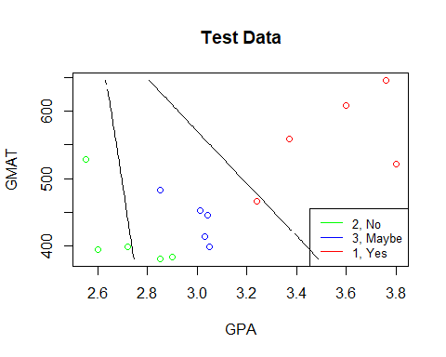

decisionplot(model, test, class = "Group", main = "LDA")

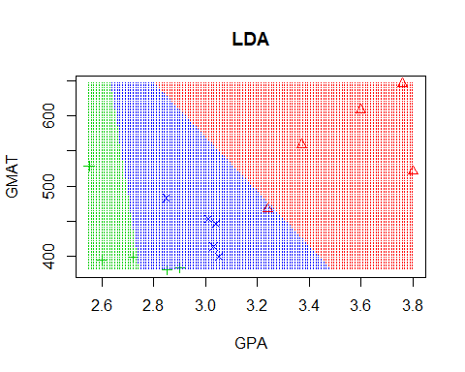

# now let us see what the plot looks like on the training set  
plot(train[,1:2], col = ifelse(train$Group != 1, ifelse(train$Group == 2, "green", "blue"), "red"))  
contour(x1.grid, x2.grid, prob1, levels = 0.5, labels = "", xlab = "", ylab = "",   
 main = "", add = T)  
contour(x1.grid, x2.grid, prob2, levels = 0.5, labels = "", xlab = "", ylab = "",   
 main = "", add = T)  
legend("topleft", legend=c("2, No", "3, Maybe", "1, Yes"),  
 col=c("green", "blue", "red"), lty=1, cex=0.8, bg="transparent")  
title("Training Data")

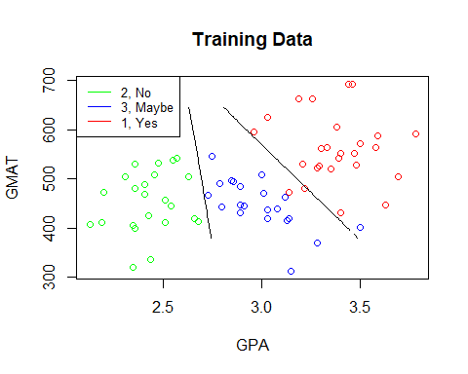

decisionplot(model, train, class = "Group", main = "LDA")

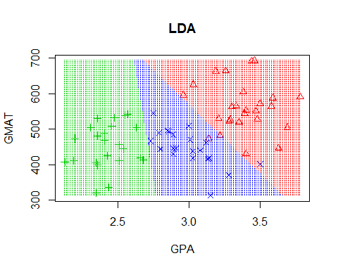

# Cool it matches the handout in elearning :D  
# now let us see on the full data  
plot(admission[,1:2], col = ifelse(admission$Group != 1, ifelse(admission$Group == 2, "green", "blue"), "red"))  
contour(x1.grid, x2.grid, prob1, levels = 0.5, labels = "", xlab = "", ylab = "",   
 main = "", add = T)  
contour(x1.grid, x2.grid, prob2, levels = 0.5, labels = "", xlab = "", ylab = "",   
 main = "", add = T)  
legend("topleft", legend=c("2, No", "3, Maybe", "1, Yes"),  
 col=c("green", "blue", "red"), lty=1, cex=0.8, bg="transparent")  
title("Admission Data")

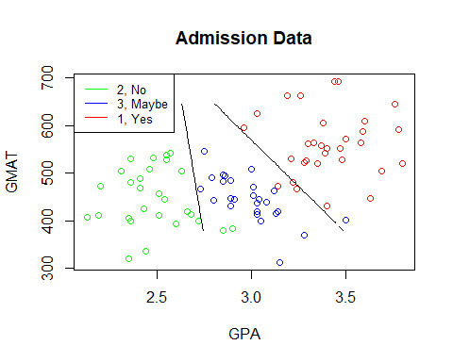

decisionplot(model, admission, class = "Group", main = "LDA")

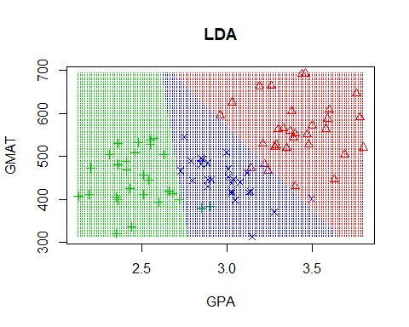

# the confusion matrix for train  
lda.pred.train <- predict(lda.fit, train)  
con.mat.train = table(lda.pred.train$class, train$Group)  
con.mat.train

##   
## 1 2 3  
## 1 24 0 1  
## 2 0 23 0  
## 3 2 0 20

# everything about how the following happens is noted under the comments in the confusion matrix for test  
class1MC = sum(con.mat.train[2],con.mat.train[3])/sum(con.mat.train)  
class2MC = sum(con.mat.train[4],con.mat.train[6])/sum(con.mat.train)  
class3MC = sum(con.mat.train[7],con.mat.train[8])/sum(con.mat.train)  
sum(class1MC,class2MC,class3MC)

## [1] 0.04285714

# the confusion matrix for test  
con.mat.test = table(lda.pred$class, test$Group)  
con.mat.test

##   
## 1 2 3  
## 1 4 0 0  
## 2 0 3 0  
## 3 1 2 5

# Overall misclassification needs to be calculated such that we:  
# for each column j, the sum of values along i when i != j is divided by sum of all elements  
# for the misclassification of class "1", we would sum rows 2 and 3 along column 1 over total obs  
# like this: (0+1)/sum(con.mat.test) = misclassification of 1.  
# we then add each class's misclassification up (because of same denominator) and get total  
class1MC = sum(con.mat.test[2],con.mat.test[3])/sum(con.mat.test)  
class2MC = sum(con.mat.test[4],con.mat.test[6])/sum(con.mat.test)  
class3MC = sum(con.mat.test[7],con.mat.test[8])/sum(con.mat.test)  
LDAmc = sum(class1MC,class2MC,class3MC)  
  
# We notice that the misclassification occurs 20% of the time in the test set, this is relatively high.  
# whereas the misclassification for train was 0.04285714. This is expected since the model fit was  
# done on the training set

# 1(c)

Same as 1(b) but now we use QDA.

set.seed(1)  
# question 1 part c ----  
# now we can perform QDA and superimpose the decision boundary!  
model <- qda(Group~ GPA + GMAT, data = train)  
qda.fit <- qda(Group ~ GPA + GMAT, data = train)  
qda.pred <- predict(qda.fit, test)  
pred.grid = predict(qda.fit, grid)  
  
# plot on test set with decision boundaries  
prob1 <- matrix(pred.grid$posterior[, 1], nrow = n.grid, ncol = n.grid, byrow = F)  
prob2 <- matrix(pred.grid$posterior[, 2], nrow = n.grid, ncol = n.grid, byrow = F)  
plot(test[,1:2], col = ifelse(test$Group != 1, ifelse(test$Group == 2, "green", "blue"), "red"))  
contour(x1.grid, x2.grid, prob1, levels = 0.5, labels = "", xlab = "", ylab = "",   
 main = "", add = T)  
contour(x1.grid, x2.grid, prob2, levels = 0.5, labels = "", xlab = "", ylab = "",   
 main = "", add = T)  
legend("bottomright", legend=c("2, No", "3, Maybe", "1, Yes"),  
 col=c("green", "blue", "red"), lty=1, cex=0.8, bg="transparent")  
title("Test Data")

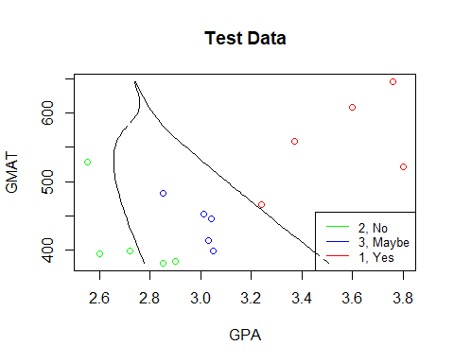

decisionplot(model, test, class = "Group", main = "QDA")

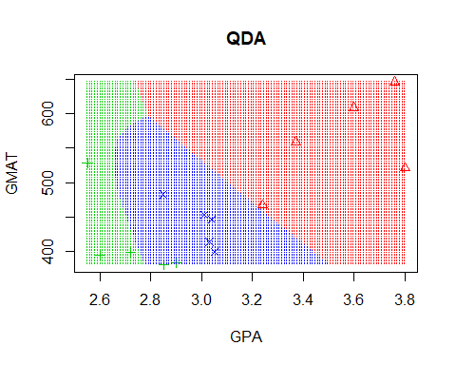

# now let us see what the plot looks like on the training set  
plot(train[,1:2], col = ifelse(train$Group != 1, ifelse(train$Group == 2, "green", "blue"), "red"))  
contour(x1.grid, x2.grid, prob1, levels = 0.5, labels = "", xlab = "", ylab = "",   
 main = "", add = T)  
contour(x1.grid, x2.grid, prob2, levels = 0.5, labels = "", xlab = "", ylab = "",   
 main = "", add = T)  
legend("topleft", legend=c("2, No", "3, Maybe", "1, Yes"),  
 col=c("green", "blue", "red"), lty=1, cex=0.8, bg="transparent")  
title("Training Data")

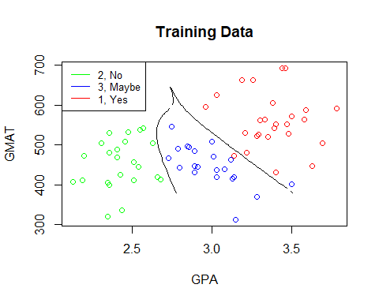

decisionplot(model, train, class = "Group", main = "QDA")

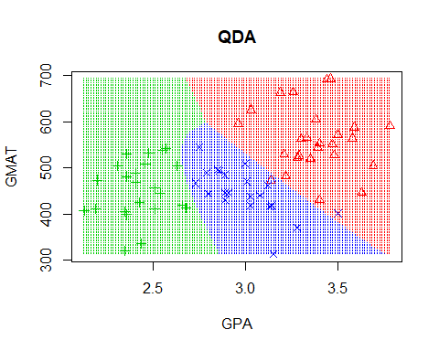

# now let us see on the full data  
plot(admission[,1:2], col = ifelse(admission$Group != 1, ifelse(admission$Group == 2, "green", "blue"), "red"))  
contour(x1.grid, x2.grid, prob1, levels = 0.5, labels = "", xlab = "", ylab = "",   
 main = "", add = T)  
contour(x1.grid, x2.grid, prob2, levels = 0.5, labels = "", xlab = "", ylab = "",   
 main = "", add = T)  
legend("topleft", legend=c("2, No", "3, Maybe", "1, Yes"),  
 col=c("green", "blue", "red"), lty=1, cex=0.8, bg="transparent")  
title("Admission Data")

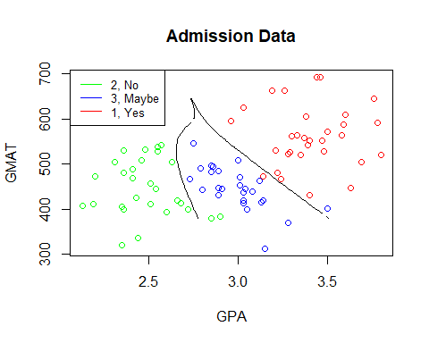

decisionplot(model, admission, class = "Group", main = "QDA")

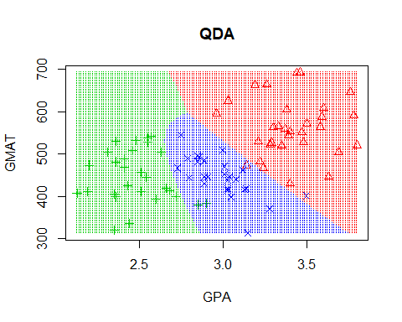

# the confusion matrix for train  
qda.pred.train <- predict(qda.fit, train)  
con.mat.train = table(qda.pred.train$class, train$Group)  
con.mat.train

##   
## 1 2 3  
## 1 25 0 1  
## 2 0 23 0  
## 3 1 0 20

class1MC = sum(con.mat.train[2],con.mat.train[3])/sum(con.mat.train)  
class2MC = sum(con.mat.train[4],con.mat.train[6])/sum(con.mat.train)  
class3MC = sum(con.mat.train[7],con.mat.train[8])/sum(con.mat.train)  
sum(class1MC,class2MC,class3MC)

## [1] 0.02857143

# the confusion matrix for test  
con.mat.test = table(qda.pred$class, test$Group)  
con.mat.test

##   
## 1 2 3  
## 1 5 0 0  
## 2 0 3 0  
## 3 0 2 5

class1MC = sum(con.mat.test[2],con.mat.test[3])/sum(con.mat.test)  
class2MC = sum(con.mat.test[4],con.mat.test[6])/sum(con.mat.test)  
class3MC = sum(con.mat.test[7],con.mat.test[8])/sum(con.mat.test)  
QDAmc = sum(class1MC,class2MC,class3MC)  
  
# We notice that the misclassification occurs 13% of the time in the test set, this is lower than lda.  
# The misclassification for train was 0.02857143. This is also lower than lda's.

# 1(d)

Same as the previous, but now with KNN. We must find an optimal K to accomplish this.

set.seed(1)  
# question 1 part d ----  
library(class)  
# now we can perform KNN and superimpose the decision boundary!  
ks = c(seq(1, nrow(test), by = 1))  
nks = length(ks)  
err.rate.train = numeric(length = nks)  
err.rate.test = numeric(length = nks)  
names(err.rate.train) = names(err.rate.test) = ks  
for (i in seq(along = ks)) {  
 mod.train = knn(train[,1:2], train[,1:2], train$Group, k = ks[i])  
 mod.test = knn(train[,1:2], test[,1:2], train$Group, k = ks[i])  
 err.rate.train[i] = 1 - sum(mod.train == train$Group)/length(train$Group)  
 err.rate.test[i] = 1 - sum(mod.test == test$Group)/length(test$Group)  
}  
# Now we want to find the optimal k using a min function  
result <- data.frame(ks, err.rate.train, err.rate.test)  
result[err.rate.test == min(result$err.rate.test), ]

## ks err.rate.train err.rate.test  
## 6 6 0.2714286 0.2666667  
## 8 8 0.3142857 0.2666667  
## 9 9 0.3571429 0.2666667  
## 10 10 0.3428571 0.2666667  
## 11 11 0.3428571 0.2666667  
## 12 12 0.4142857 0.2666667  
## 13 13 0.3857143 0.2666667  
## 15 15 0.4142857 0.2666667

# It appears we can get away with k = 6, our optimal k  
knn.fit <- knn(train[,1:2], test[,1:2], train$Group, k = 6, prob = T)  
# the following knn.prob would really only get used for an ROC curve, nonetheless its nice to see it work for this data  
knn.prob <- attr(knn.fit, "prob") # prob is voting fraction for winning class  
# the following is not the same as knn.prob <- ifelse(knn.fit == 1, knn.prob, 1 - knn.prob)  
knn.prob <- ifelse(knn.fit != 1,   
 ifelse(knn.fit == 2, 1-knn.prob[knn.fit==2],1-knn.prob[knn.fit==3]),  
 knn.prob) # now it is voting fraction for Group == 1  
# We now have enough information to compute the confusion matrix  
# the confusion matrix for train  
knn.fit.train <- knn(train[,1:2], train[,1:2], train$Group, k = 6, prob = T)  
con.mat.train = table(knn.fit.train, train$Group)  
con.mat.train

##   
## knn.fit.train 1 2 3  
## 1 22 2 1  
## 2 2 14 7  
## 3 2 7 13

class1MC = sum(con.mat.train[2],con.mat.train[3])/sum(con.mat.train)  
class2MC = sum(con.mat.train[4],con.mat.train[6])/sum(con.mat.train)  
class3MC = sum(con.mat.train[7],con.mat.train[8])/sum(con.mat.train)  
sum(class1MC,class2MC,class3MC)

## [1] 0.3

# the confusion matrix for test  
con.mat.test = table(knn.fit, test$Group)  
con.mat.test

##   
## knn.fit 1 2 3  
## 1 4 1 0  
## 2 0 4 3  
## 3 1 0 2

class1MC = sum(con.mat.test[2],con.mat.test[3])/sum(con.mat.test)  
class2MC = sum(con.mat.test[4],con.mat.test[6])/sum(con.mat.test)  
class3MC = sum(con.mat.test[7],con.mat.test[8])/sum(con.mat.test)  
KNNmc = sum(class1MC,class2MC,class3MC)  
  
# We notice that the misclassification occurs 33% of the time in the test set, this is worse than lda and qda.  
# The misclassification for train was 0.3. This is nearly as bad as its test set!  
  
# now plot for knn  
model <- knn3(Group ~ GPA+GMAT, data=train, k = 6)  
pred.grid = predict(model, grid)  
  
# plot on test set with decision boundaries  
prob1 <- matrix(pred.grid[, 1], nrow = n.grid, ncol = n.grid, byrow = F)  
prob2 <- matrix(pred.grid[, 2], nrow = n.grid, ncol = n.grid, byrow = F)  
plot(test[,1:2], col = ifelse(test$Group != 1, ifelse(test$Group == 2, "green", "blue"), "red"))  
contour(x1.grid, x2.grid, prob1, levels = 0.5, labels = "", xlab = "", ylab = "",   
 main = "", add = T)  
contour(x1.grid, x2.grid, prob2, levels = 0.5, labels = "", xlab = "", ylab = "",   
 main = "", add = T)  
legend("bottomright", legend=c("2, No", "3, Maybe", "1, Yes"),  
 col=c("green", "blue", "red"), lty=1, cex=0.8, bg="transparent")  
title("Test Data")

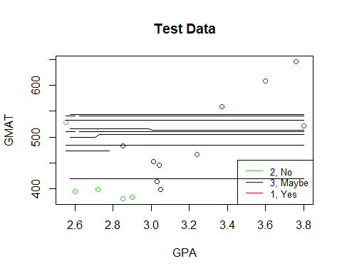

decisionplot(model, test, class = "Group", main = "kNN (6)")

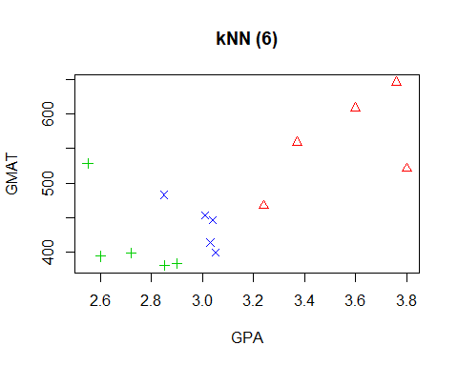

# it does not look like the decision boundary worked correctly on either method here  
# We have suppressed the next graphs due to this problem.

# 1(e)

Now we want to compare all of the models

set.seed(1)  
# question 1 part e ----  
models = c("Misclassification test Rate")  
rbind(models, LDAmc, QDAmc, KNNmc)

## [,1]   
## models "Misclassification test Rate"  
## LDAmc "0.2"   
## QDAmc "0.133333333333333"   
## KNNmc "0.333333333333333"

# QDA gives a nice result, but LDA isn't very far off and is technically a simpler method.  
# I would personally recommend LDA on the basis of simplicity as well as leniency  
# for the no and maybe categories :)

# Question 2(a)

Here we explore this new data set and determine what variables will be good for predicting/response.

set.seed(1)  
# question 2 part a ----  
library(corrplot)  
bankruptcy = read.csv("bankruptcy.csv", header = T)  
# delete out the useless x varialbes  
bankruptcy$X = bankruptcy$X.1 <- NULL  
head(bankruptcy)

## X1 X2 X3 X4 Group  
## 1 -0.45 -0.41 1.09 0.45 0  
## 2 -0.56 -0.31 1.51 0.16 0  
## 3 0.06 0.02 1.01 0.40 0  
## 4 -0.07 -0.09 1.45 0.26 0  
## 5 -0.10 -0.09 1.56 0.67 0  
## 6 -0.14 -0.07 0.71 0.28 0

str(bankruptcy)

## 'data.frame': 46 obs. of 5 variables:  
## $ X1 : num -0.45 -0.56 0.06 -0.07 -0.1 -0.14 0.04 -0.07 0.07 -0.14 ...  
## $ X2 : num -0.41 -0.31 0.02 -0.09 -0.09 -0.07 0.01 -0.06 -0.01 -0.14 ...  
## $ X3 : num 1.09 1.51 1.01 1.45 1.56 0.71 1.5 1.37 1.37 1.42 ...  
## $ X4 : num 0.45 0.16 0.4 0.26 0.67 0.28 0.71 0.4 0.34 0.43 ...  
## $ Group: int 0 0 0 0 0 0 0 0 0 0 ...

summary(bankruptcy)

## X1 X2 X3 X4   
## Min. :-0.5600 Min. :-0.410000 Min. :0.330 Min. :0.1300   
## 1st Qu.:-0.0700 1st Qu.:-0.052500 1st Qu.:1.370 1st Qu.:0.2850   
## Median : 0.1200 Median : 0.035000 Median :1.935 Median :0.4250   
## Mean : 0.0963 Mean :-0.006957 Mean :2.033 Mean :0.4317   
## 3rd Qu.: 0.2150 3rd Qu.: 0.070000 3rd Qu.:2.425 3rd Qu.:0.5475   
## Max. : 0.5800 Max. : 0.140000 Max. :5.060 Max. :0.9500   
## Group   
## Min. :0.0000   
## 1st Qu.:0.0000   
## Median :1.0000   
## Mean :0.5435   
## 3rd Qu.:1.0000   
## Max. :1.0000

pairs(subset(bankruptcy))

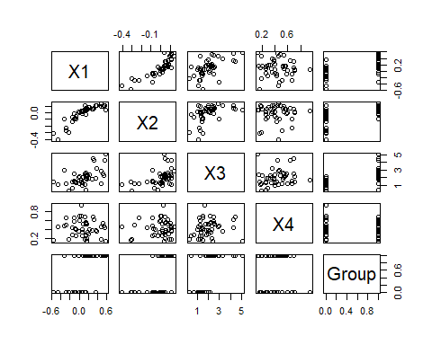

round(cor(subset(bankruptcy)), 2)

## X1 X2 X3 X4 Group  
## X1 1.00 0.86 0.57 -0.05 0.59  
## X2 0.86 1.00 0.47 0.05 0.56  
## X3 0.57 0.47 1.00 0.15 0.61  
## X4 -0.05 0.05 0.15 1.00 -0.03  
## Group 0.59 0.56 0.61 -0.03 1.00

corrplot(cor(subset(bankruptcy)), method = "number", type = "upper")

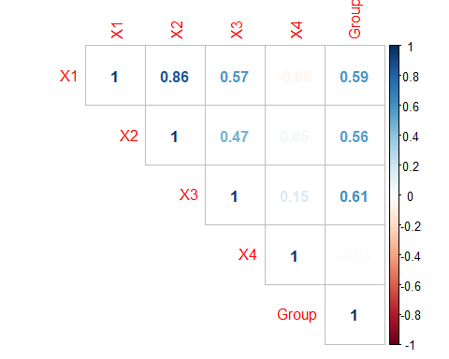

# it appears that all variables but x4 would be good to predict group with

# 2(b)

We test full and null model alongside some variable selection model to determine a good model to predict bankruptcy.

set.seed(1)  
# question 2 part b ----  
attach(bankruptcy)

## The following object is masked from admission:  
##   
## Group

fit1 <- glm(Group ~., family = binomial, data = bankruptcy)  
summary(fit1)

##   
## Call:  
## glm(formula = Group ~ ., family = binomial, data = bankruptcy)  
##   
## Deviance Residuals:   
## Min 1Q Median 3Q Max   
## -2.30416 -0.44545 0.00725 0.49102 2.62396   
##   
## Coefficients:  
## Estimate Std. Error z value Pr(>|z|)   
## (Intercept) -5.320 2.366 -2.248 0.02459 *   
## X1 7.138 6.002 1.189 0.23433   
## X2 -3.703 13.670 -0.271 0.78647   
## X3 3.415 1.204 2.837 0.00455 **  
## X4 -2.968 3.065 -0.968 0.33286   
## ---  
## Signif. codes: 0 '***' 0.001 '**' 0.01 '*' 0.05 '.' 0.1 ' ' 1  
##   
## (Dispersion parameter for binomial family taken to be 1)  
##   
## Null deviance: 63.421 on 45 degrees of freedom  
## Residual deviance: 27.443 on 41 degrees of freedom  
## AIC: 37.443  
##   
## Number of Fisher Scoring iterations: 7

# par(mfrow = c(2,2))  
# plot(fit1) # to be used if we want to verify model assumptions  
fit2 = glm(Group ~X1+X3, family = binomial, data = bankruptcy)  
summary(fit2)

##   
## Call:  
## glm(formula = Group ~ X1 + X3, family = binomial, data = bankruptcy)  
##   
## Deviance Residuals:   
## Min 1Q Median 3Q Max   
## -2.26853 -0.47678 0.00942 0.48365 2.70538   
##   
## Coefficients:  
## Estimate Std. Error z value Pr(>|z|)   
## (Intercept) -5.940 1.985 -2.992 0.00277 **  
## X1 6.556 2.905 2.257 0.02402 *   
## X3 3.019 1.002 3.013 0.00259 **  
## ---  
## Signif. codes: 0 '***' 0.001 '**' 0.01 '*' 0.05 '.' 0.1 ' ' 1  
##   
## (Dispersion parameter for binomial family taken to be 1)  
##   
## Null deviance: 63.421 on 45 degrees of freedom  
## Residual deviance: 28.636 on 43 degrees of freedom  
## AIC: 34.636  
##   
## Number of Fisher Scoring iterations: 6

fit3 = glm(Group ~ 1, family = binomial, data = bankruptcy)  
summary(fit3)

##   
## Call:  
## glm(formula = Group ~ 1, family = binomial, data = bankruptcy)  
##   
## Deviance Residuals:   
## Min 1Q Median 3Q Max   
## -1.252 -1.252 1.104 1.104 1.104   
##   
## Coefficients:  
## Estimate Std. Error z value Pr(>|z|)  
## (Intercept) 0.1744 0.2960 0.589 0.556  
##   
## (Dispersion parameter for binomial family taken to be 1)  
##   
## Null deviance: 63.421 on 45 degrees of freedom  
## Residual deviance: 63.421 on 45 degrees of freedom  
## AIC: 65.421  
##   
## Number of Fisher Scoring iterations: 3

# compare fit 2 and 1  
anova(fit2, fit1, test = "Chisq")

## Analysis of Deviance Table  
##   
## Model 1: Group ~ X1 + X3  
## Model 2: Group ~ X1 + X2 + X3 + X4  
## Resid. Df Resid. Dev Df Deviance Pr(>Chi)  
## 1 43 28.636   
## 2 41 27.443 2 1.1924 0.5509

# since we accept the H0 we keep the reduced model fit2  
# compare fit 2 with fit 3 (null model)  
anova(fit2, fit3, test = "Chisq")

## Analysis of Deviance Table  
##   
## Model 1: Group ~ X1 + X3  
## Model 2: Group ~ 1  
## Resid. Df Resid. Dev Df Deviance Pr(>Chi)   
## 1 43 28.636   
## 2 45 63.421 -2 -34.786 2.795e-08 ***  
## ---  
## Signif. codes: 0 '***' 0.001 '**' 0.01 '*' 0.05 '.' 0.1 ' ' 1

# since we reject the H0 we keep the full model fit2  
# Since we are using all of the data as training data, there is no need to split  
  
# It seems cash flow and current assets over current liabilities determine bankruptcy the best.  
# This can be seen as does one have enough compensation for their given risk.

# Question 3(a)

Our goal is to use the previous question’s logistic regression model for a decision boundary equation,  
confusion matrix, sensitivity, specificity, misclassification rate, and ROC curve.  
Noted in the comments, we decided to split data 50/50 for train/test in order to achieve  
meaningful numbers. If tested and trained on the full data, the numbers are more or less the same for each model.

set.seed(1)  
# question 3 part a ----  
# put latex equation for decision boundary here  
  
# if we proceed with our training data == test data then our following  
# outcomes on each model will be the same (tested) almost as if it were copied and pasted  
# so we will split the data down the middle, 50/50 training/testing.   
# There is no motivation for using 50/50, simply using for fun  
  
# split data 50/50, train/test  
set.seed(1)  
n = nrow(bankruptcy)  
sampler = sample(1:n, n/2) # n/2 is the 50/50 splitter  
train = bankruptcy[sampler, ]  
test = bankruptcy[-sampler, ]  
  
# create model  
fit = glm(Group ~X1+X3, family = binomial, data = train)  
  
# Estimated probabilities for test data  
prob <- predict(fit, test, type = "response")  
  
# Predicted classes (using 0.5 cutoff)  
pred <- ifelse(prob >= 0.5, "nonbankrupt", "bankrupt")  
  
# Test error rate  
1 - mean(pred == test[, "Group"])

## [1] 1

# Confusion matrix and (sensitivity, specificity)  
# `+' = nonbankrupt, `-' = bankrupt  
con.mat = table(pred, test[, "Group"])  
con.mat

##   
## pred 0 1  
## bankrupt 10 2  
## nonbankrupt 1 10

# PRED CLASS  
# TRUE TN FP  
# CLASS FN TP  
# Sensitivity, TP/P = 0.8333333  
10/(10+2)

## [1] 0.8333333

con.mat[4]/sum(con.mat[3],con.mat[4])

## [1] 0.8333333

# Specificity, TN/N = 0.9090909  
10/(10+1)

## [1] 0.9090909

con.mat[1]/sum(con.mat[1],con.mat[2])

## [1] 0.9090909

# Overall misclassification, (FN+FP)/(N+P) = 0.1304348  
# or (1-sens)*[P/(P+N)]+(1-spec)*[N/(P+N)] = 0.1304348  
(1+2)/(11+12)

## [1] 0.1304348

sum(con.mat[2],con.mat[3])/sum(con.mat)

## [1] 0.1304348

# Misclassification is not bad, we will see how it ranks against the next models  
  
# ROC curve  
# case = '+' (or nonbankrupt, 1) , control = '-' (or bankrupt, 0)  
library(pROC)

## Type 'citation("pROC")' for a citation.

##   
## Attaching package: 'pROC'

## The following objects are masked from 'package:stats':  
##   
## cov, smooth, var

roc <- roc(test[, "Group"], prob, levels = c(0, 1))  
plot(roc, legacy.axes = T)

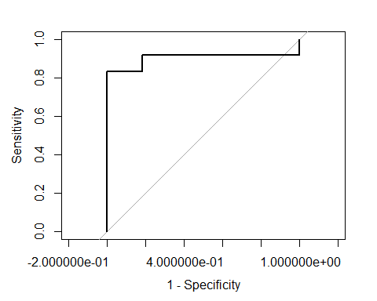

lr_red = c("LR reduced", sum(con.mat[2],con.mat[3])/sum(con.mat), roc$auc)

# 3(b)

We perform the same analysis as 3(a), but now with all predictors. We note in comments about comparison.

set.seed(1)  
# question 3 part b ----  
# put latex equation for decision boundary here  
  
# create model with all predictors  
fit = glm(Group ~., family = binomial, data = train)  
  
# Estimated probabilities for test data  
prob <- predict(fit, test, type = "response")  
  
# Predicted classes (using 0.5 cutoff)  
pred <- ifelse(prob >= 0.5, "nonbankrupt", "bankrupt")  
  
# Test error rate  
1 - mean(pred == test[, "Group"])

## [1] 1

# Confusion matrix and (sensitivity, specificity)  
# `+' = nonbankrupt, `-' = bankrupt  
con.mat = table(pred, test[, "Group"])  
con.mat

##   
## pred 0 1  
## bankrupt 9 2  
## nonbankrupt 2 10

# PRED CLASS  
# TRUE TN FP  
# CLASS FN TP  
# Sensitivity, TP/P = 0.8333333  
con.mat[4]/sum(con.mat[3],con.mat[4])

## [1] 0.8333333

# Specificity, TN/N = 0.8181818  
con.mat[1]/sum(con.mat[1],con.mat[2])

## [1] 0.8181818

# Overall misclassification, (FN+FP)/(N+P) = 0.173913  
# or (1-sens)*[P/(P+N)]+(1-spec)*[N/(P+N)] = 0.173913  
sum(con.mat[2],con.mat[3])/sum(con.mat)

## [1] 0.173913

# ROC curve  
# case = '+' (or nonbankrupt, 1) , control = '-' (or bankrupt, 0)  
roc <- roc(test[, "Group"], prob, levels = c(0, 1))  
plot(roc, legacy.axes = T)

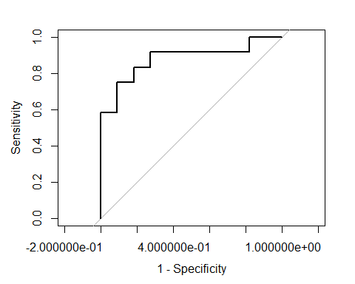

lr_ful = c("LR full", sum(con.mat[2],con.mat[3])/sum(con.mat), roc$auc)  
  
# Misclassification i higher than the previous model, as we would expect.  
# It would appear that variable selection plays a large role in making a good model  
# Our specificity has fallen due to this overfitted model  
# but our sensitivity is the same. Also the ROC curve is further from the left corner  
# which indicates a drop in performance using this model

# 3(c)

We perform same analysis as in 3(b), but now using Linear Discriminant Analysis (LDA).

set.seed(1)  
# question 3 part c ----  
# put latex equation for decision boundary here  
  
# create model with all predictors  
library(MASS)  
fit = lda(Group ~ ., data = train)  
  
# Estimated probabilities for test data  
# lda function already has the next steps within, so we can compute con.mat directly from this prob  
prob <- predict(fit, test) # seems to result in same output with/without type = "response"  
  
# Predicted classes (using 0.5 cutoff)  
pred <- ifelse(prob$posterior[,2] >= 0.5, "nonbankrupt", "bankrupt")  
  
# Test error rate  
1 - mean(pred == test[, "Group"])

## [1] 1

# Confusion matrix and (sensitivity, specificity)  
# `+' = nonbankrupt, `-' = bankrupt  
con.mat = table(pred, test[, "Group"])  
con.mat

##   
## pred 0 1  
## bankrupt 8 2  
## nonbankrupt 3 10

# PRED CLASS  
# TRUE TN FP  
# CLASS FN TP  
# Sensitivity, TP/P = 0.8333333  
con.mat[4]/sum(con.mat[3],con.mat[4])

## [1] 0.8333333

# Specificity, TN/N = 0.7272727  
con.mat[1]/sum(con.mat[1],con.mat[2])

## [1] 0.7272727

# Overall misclassification, (FN+FP)/(N+P) = 0.2173913  
# or (1-sens)*[P/(P+N)]+(1-spec)*[N/(P+N)] = 0.2173913  
sum(con.mat[2],con.mat[3])/sum(con.mat)

## [1] 0.2173913

# ROC curve  
# case = '+' (or nonbankrupt, 1) , control = '-' (or bankrupt, 0)  
library(pROC)  
roc <- roc(test[, "Group"], prob$posterior[,2], levels = c(0, 1))  
plot(roc, legacy.axes = T)

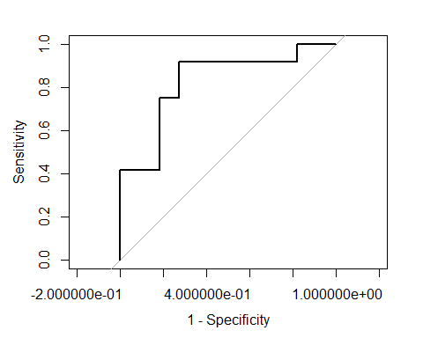

LDA = c("LDA", sum(con.mat[2],con.mat[3])/sum(con.mat), roc$auc)  
  
# Sensitivity is the same once again, specificity has fallen even more from the previous model. Misclassification is highest on LDA so far.  
# This perhaps indicates a linear model is not a good fit for this data.

# 3(d)

Same analysis as previoius, but now using Quadratic Discriminant Analysis (QDA).

set.seed(1)  
# question 3 part d ----  
# put latex equation for decision boundary here  
  
# create model with all predictors  
library(MASS)  
fit = qda(Group ~ ., data = train)  
  
# Estimated probabilities for test data  
# qda function already has the next steps within, so we can compute con.mat directly from this prob  
prob <- predict(fit, test) # seems to result in same output with/without type = "response"  
  
# Predicted classes (using 0.5 cutoff)  
pred <- ifelse(prob$posterior[,2] >= 0.5, "nonbankrupt", "bankrupt")  
  
# Test error rate  
1 - mean(pred == test[, "Group"])

## [1] 1

# Confusion matrix and (sensitivity, specificity)  
# `+' = nonbankrupt, `-' = bankrupt  
con.mat = table(pred, test[, "Group"])  
con.mat

##   
## pred 0 1  
## bankrupt 9 2  
## nonbankrupt 2 10

# PRED CLASS  
# TRUE TN FP  
# CLASS FN TP  
# Sensitivity, TP/P = 0.8333333  
con.mat[4]/sum(con.mat[3],con.mat[4])

## [1] 0.8333333

# Specificity, TN/N = 0.8181818  
con.mat[1]/sum(con.mat[1],con.mat[2])

## [1] 0.8181818

# Overall misclassification, (FN+FP)/(N+P) = 0.173913  
# or (1-sens)*[P/(P+N)]+(1-spec)*[N/(P+N)] = 0.173913  
sum(con.mat[2],con.mat[3])/sum(con.mat)

## [1] 0.173913

# ROC curve  
# case = '+' (or nonbankrupt, 1) , control = '-' (or bankrupt, 0)  
library(pROC)  
roc <- roc(test[, "Group"], prob$posterior[,2], levels = c(0, 1))  
plot(roc, legacy.axes = T)

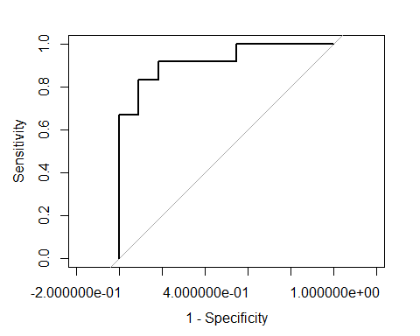

QDA = c("QDA", sum(con.mat[2],con.mat[3])/sum(con.mat), roc$auc)  
  
# Again Sensitivity is the same, interesting. Specificity has come up from LDA model, looks to be where full logistic regression model is.  
# Overall misclassification has gone back down as well, further exemplifying a linear model is not best for this data.

# 3(e)

Finally, we compare each model using Area under the curve and overall misclassification rate.

set.seed(1)  
# question 3 part e ----  
# From previous parts we look at who has the best AUC (area under the curve) and lowest misclassification  
# To summarize here are the results  
names = c("Model", "Misclassification Rate", "Area Under the Curve")  
models = rbind(names, lr_red, lr_ful, LDA, QDA)  
models

## [,1] [,2] [,3]   
## names "Model" "Misclassification Rate" "Area Under the Curve"  
## lr_red "LR reduced" "0.130434782608696" "0.901515151515151"   
## lr_ful "LR full" "0.173913043478261" "0.878787878787879"   
## LDA "LDA" "0.217391304347826" "0.825757575757576"   
## QDA "QDA" "0.173913043478261" "0.924242424242424"

# It appears that the reduced logistic regression model is the best selection of all choices  
# due to having small misclassification rate and high AUC. However, QDA has an even higher AUC but at a cost of misclassification rate.  
# This is a nice expectation because logistic regression is very good at modelling binary responses; we only have bankrupt and not bankrupt to fit.  
# It also makes sense that the reduced model did better than the full model since it avoided overfitting problems typically associated with using  
# all predictors. This is nice because we can have inference on our coefficients and intuition on the predictors.